**Assignment 5**

**Draw the activity diagram for the specified Case Study**.

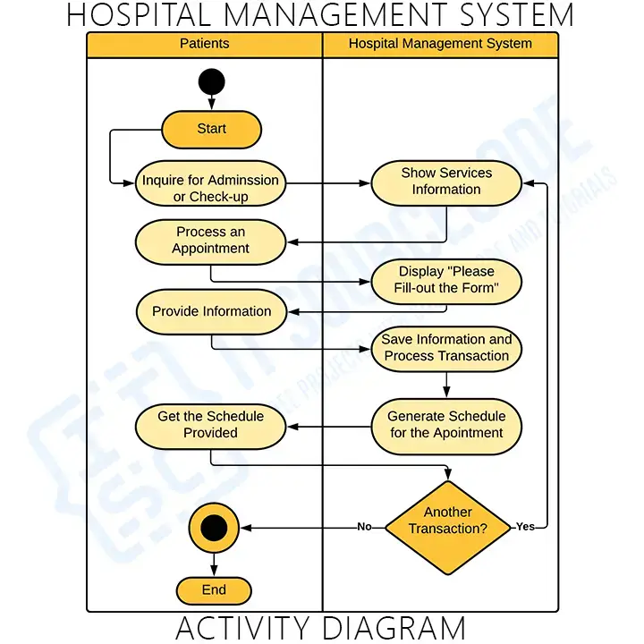

**Activity Diagram for the Patient Users**

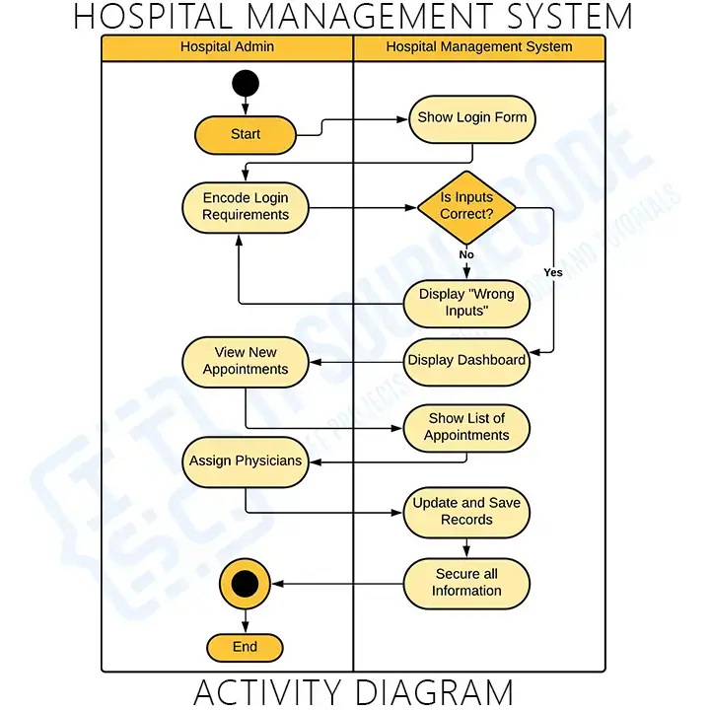

**Activity diagram for admin**